3D Structural Biology Hackathon
Final Research Report

Submitted by:
Sivan Mor Yosef – 212877468
Yair Mahfud - 207807082
Lior Zats – 209226448
Yuval Cohen – 208305052

Instructors:
Dr. Barak Raveh
Prof. Dina Schneidman

Introduction
In our previous work, we developed a binary classifier for Nuclear Export Signal (NES) prediction using ESM protein language model embeddings trained on approximately 500 peptide sequences. The model distinguishes peptides containing NES motifs from those without, leveraging the rich contextual information captured by ESM-2 embeddings. This peptide-level classification provided an initial framework for NES recognition at the sequence level and demonstrated the potential of transformer-based protein models for this task.
Our motivation extends beyond peptide-level classification toward the more biologically relevant goal of protein-level NES prediction. In biological systems, the focus is typically on whether an entire protein has nuclear export capability. Protein-level classification enables more meaningful insights, such as predicting protein subcellular localization, understanding nuclear-cytoplasmic transport, and identifying disease-related proteins. This shift is essential for developing clinically relevant tools to study nuclear transport biology.
Accurate protein-level NES prediction is directly relevant to CRM1 nuclear export, a key transport pathway. Proteins with NES motifs are recognized and exported by CRM1, and disruption of this pathway is implicated in cancer through altered nuclear-cytoplasmic transport and therapeutic resistance ^{[1]}. Beyond binary classification, our approach identifies specific NES positions within protein sequences, providing spatial detail essential for understanding structure-function relationships, designing targeted interventions, and predicting the impact of mutations on nuclear export ^{[2]}.
However, our peptide-level classifier has limitations. The dataset is relatively small (~500 examples), which may restrict the diversity of NES motifs it can learn. Additionally, the negative examples were randomly generated rather than experimentally validated, potentially weakening the model’s ability to differentiate true negatives. Finally, moving from peptide- to protein-level prediction introduces challenges, as aggregating hundreds of peptide predictions per protein can amplify errors, underscoring the need for highly accurate peptide-level predictions.

Methods
In this project, we aimed to develop a robust and systematic workflow to achieve accurate classification of proteins containing nuclear export signals (NES). Throughout the process, we encountered various challenges due to the scale and complexity of the data, and we continuously refined our approach to address them.
We began by working with a dataset of 4,000 proteins — a substantial volume, particularly considering the need to segment each protein into its corresponding peptides. The first phase involved thorough pre-processing of the dataset: extracting peptides associated with each protein, and accurately labeling these peptides according to their true classification (presence or absence of NES elements).
Following this data preparation, we proceeded to the evaluation stage. Our strategy was to advance the model by iteratively analyzing its performance and predictive accuracy. The processing pipeline involved several key steps:
- segmenting proteins into peptides,
- generating embeddings for each peptide using the ESM-2 protein language model,
- applying a scoring function with a dynamic threshold to produce predictions,
- and computing overall classification accuracy at the protein level.
During the last phase, we also conducted an additional experiment: we introduced a modification to control the number of peptides required for a protein to be classified as positive (i.e., containing NES). This adjustment was motivated by the observation that some proteins contained a disproportionately large number of peptides, which could bias the classification outcome. By imposing a limit on the minimum number of peptides needed to assign a positive label, we improved classification stability. Although this step was successful, it is considered more of an experimental adjustment rather than a core component of our methods.
A key part of our overall approach was the iterative refinement of the training data. After each evaluation cycle, we enhanced the dataset — in particular, by curating improved sets of negative examples — in order to create a more balanced and representative training set. This process helped the model generalize better and achieve higher accuracy over time.
The final objective of our workflow is to deploy the optimized model on a larger dataset of 20,000 proteins, enabling us to determine, with improved reliability, whether each protein contains NES elements or not. The design of this workflow — centered around evaluation, iterative learning, and correction — provides a well-balanced framework for progressing toward this goal.

Experiments
The following plots summarize the key stages and evaluation metrics of our Nuclear Export Signal (NES) prediction pipeline:
- Dataset Preparation: We began with a dataset of approximately 4,000 proteins experimentally annotated for NES content. Each protein sequence was segmented into overlapping peptides using a sliding window of 22 amino acids (stride = 1). Ambiguous peptides were excluded to ensure high-confidence supervision, resulting in a labeled dataset of NES-positive and NES-negative peptides.
- Feature Extraction: Each peptide was embedded using the ESM-2 protein language model (layer 9), producing a 2,560-dimensional vector representation per peptide.
- Peptide Classification: A neural network classifier (SimpleDenseNet) was trained to predict NES presence at the peptide level based on these embeddings.
- Protein-Level Prediction: Protein classification was initially determined using a simple rule: if any peptide within a protein was classified as NES-positive, the entire protein was labeled as NES-containing.
- NES Localization: Predicted NES regions were extracted by mapping the coordinates of positively predicted peptides back to their original positions within the protein sequence.
These visualizations demonstrate the model’s ability to detect NES-containing proteins and accurately localize NES regions with high sensitivity.

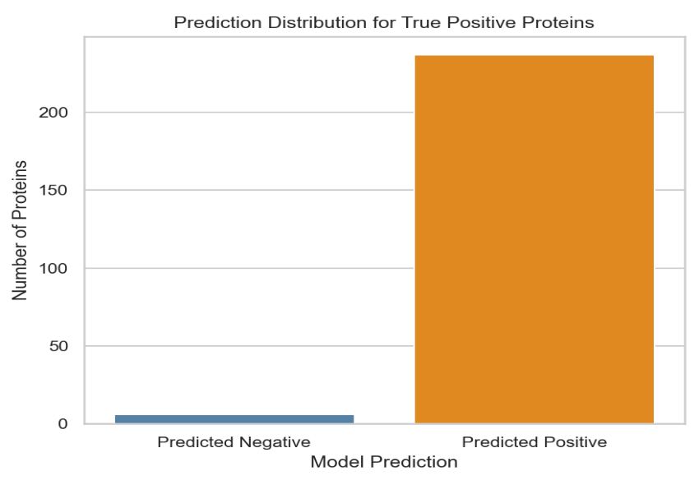
🟦 Figure 1: Prediction Distribution for True Positive Proteins

This plot displays the model’s performance on proteins that are truly NES-positive. Here, the model performs very well, correctly identifying the vast majority of them. Only a small number of false negatives are observed, indicating high recall (sensitivity).
🟧 Figure 2: Prediction Distribution for True Negative Proteins
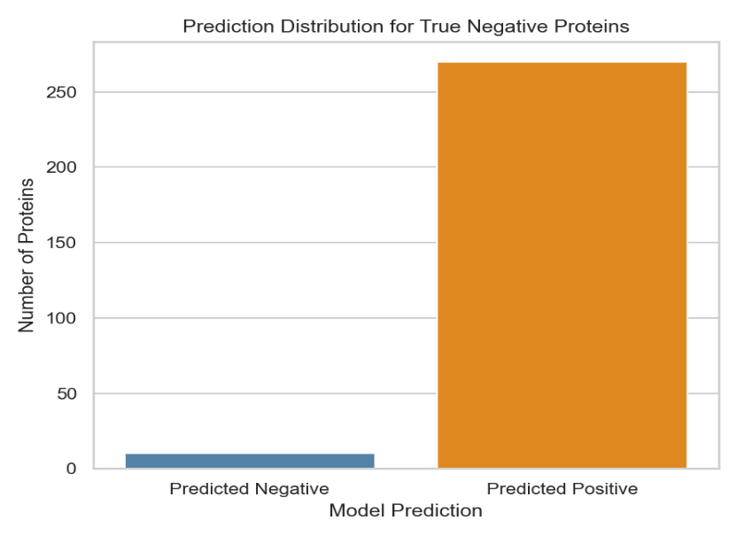

This plot shows the model’s predictions for truly negative proteins—those without a Nuclear Export Signal (NES). Despite their negative labels, most were misclassified as positive, indicating a high false positive rate. This is a direct result of the model’s “one-positive-peptide” decision rule: a protein is classified as NES-positive if even a single peptide scores highly. Since proteins typically contain hundreds of overlapping peptides, a single noisy or erroneously high-scoring peptide is often enough to cause a false positive.
This observation motivates the next plot, where we explore whether requiring a minimum number or proportion of positive peptides can improve prediction reliability.
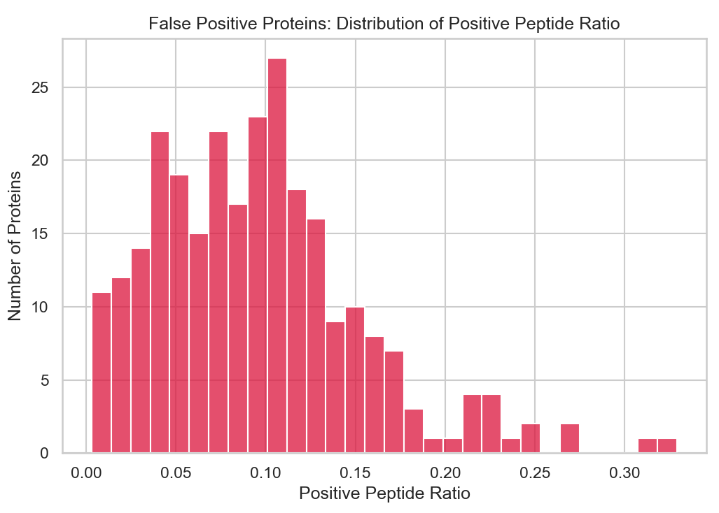
🟥 Figure 3: False Positive Proteins – Distribution of Positive Peptide Ratio

This plot shows how many negative proteins were wrongly predicted as positive, based on the proportion of their peptides classified as positive.
We observe an inverse relationship: the fewer positive peptides a protein has, the more likely it is a false positive. Most of these errors occurred when only a small fraction (under 10%) of peptides were predicted as positive—often due to a single noisy peptide.
This reflects a weakness in the model’s original “one-positive-peptide” rule: if any peptide is positive, the whole protein is marked positive. Since true NES signals span several overlapping peptides, isolated positives are often errors.
To address this, we revised the rule: a protein is now predicted as positive only if at least 20% of its peptides are classified as positive—reducing false positives without severely harming recall.
Updated Results After Applying the 20% Peptide Threshold Rule:
To mitigate the high false positive rate observed under the original “one-positive-peptide” policy, we revised the protein-level decision rule. Instead of marking a protein as NES-positive if any peptide is classified as positive, we now require at least 20% of the protein's peptides to be predicted as positive.
🟧 Figure 4: Prediction Distribution for True Negative Proteins
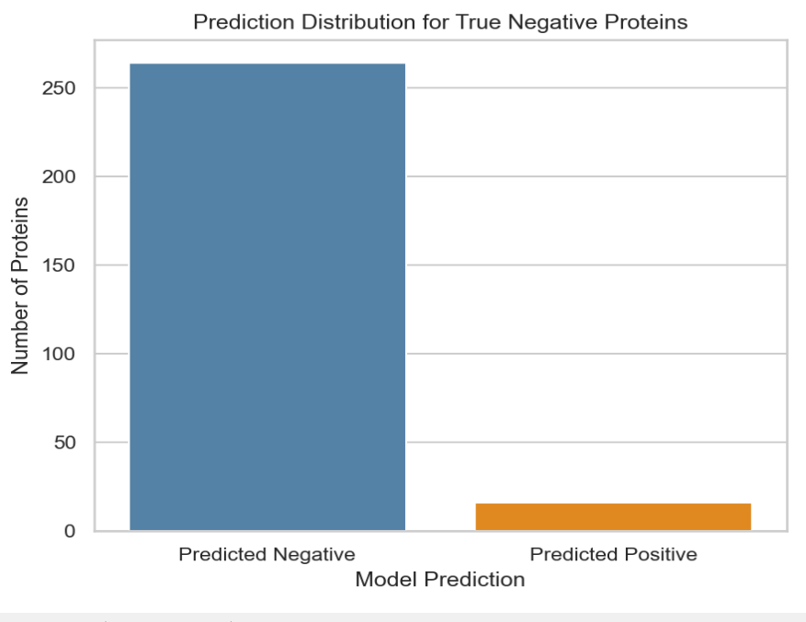

This plot shows a significant improvement in specificity: the vast majority of truly negative proteins are now correctly classified as negative. The false positive count dropped drastically, indicating that requiring multiple positive peptides effectively filters out spurious signals from isolated noisy peptides

🟧 Figure 5: Prediction Distribution for True Positive Proteins
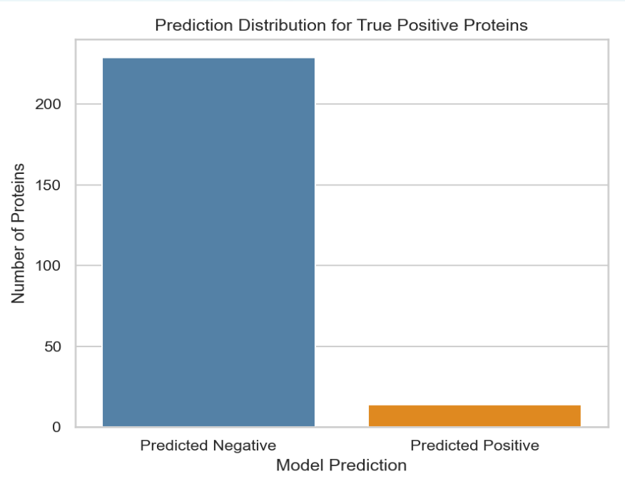

While false positives decreased, this improvement came at a cost. The number of false negatives (true positives incorrectly predicted as negative) increased considerably. This suggests a loss in recall, as some true NES proteins no longer meet the 20% threshold—even though they may still contain valid NES regions.
🟧 Figure 6: False Positive Proteins – Positive Peptide Ratio
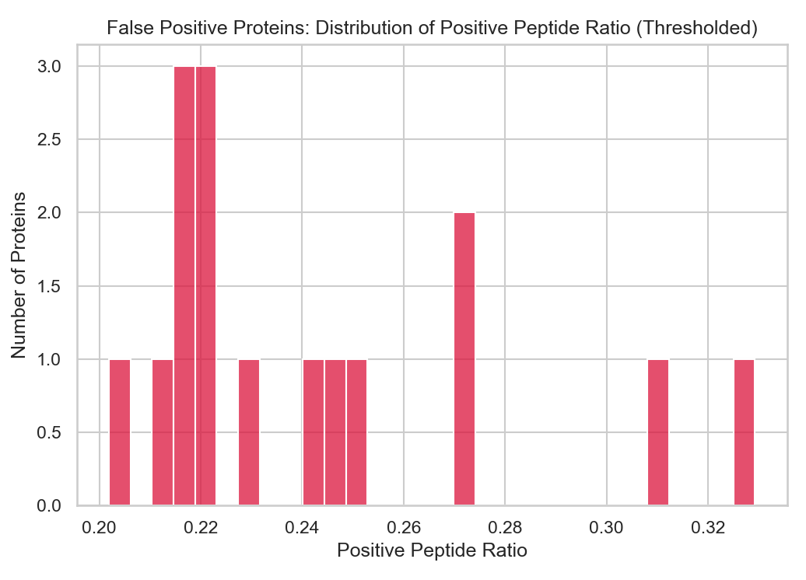

This histogram now shows that only a handful of false positives remain, and they barely pass the 20% threshold. This supports the effectiveness of the revised rule in eliminating weak, noisy signals. However, the sharp drop also implies that the threshold might be too strict, and that a dynamic or learned threshold could be a promising direction for future improvement.
Model assessment
While applying the 20% peptide threshold rule substantially improved specificity and reduced false positives, this improvement came at the expense of sensitivity. The model now fails to detect a significant portion of truly NES-positive proteins—suggesting that the revised rule, although effective in filtering noise, is overly conservative for many borderline cases.
This trade-off highlights an inherent limitation of the current model architecture and peptide-to-protein aggregation strategy. We tested both extremes—liberal (≥1 positive peptide) and conservative (≥20% positive peptides)—and observed that neither yields balanced performance. This suggests that the model, as currently trained, lacks sufficient discriminative capacity to support reliable protein-level NES classification.
To achieve better performance, future work should explore retraining or rearchitecting the model, potentially incorporating more sophisticated aggregation logic or peptide context-aware mechanisms.
Case Example – AP3D1
AP3D1 is a core subunit of the adaptor protein complex AP-3, which plays essential roles in vesicle formation at the Golgi, neuronal trafficking, and immune regulation.
This protein was correctly predicted as NES-positive by our model.
Moreover, our predicted NES regions (e.g., residues 58–86, 207–243, 562–592) include multiple high-confidence overlapping peptides (scores > 0.99), highlighting the model's capacity to capture biologically meaningful NES sites.
AP3D1 is a multifunctional protein with two main roles: vesicle targeting and regulation of the AP-3 complex. As part of the AP-3 adaptor complex, AP3D1 helps direct cargo to specific destinations such as lysosomes, melanosomes, synaptic vesicles, and immune granules—ensuring efficient intracellular trafficking^{[3]}. In addition, AP3D1 is involved in assembling, regulating, and ensuring the quality of the AP-3 complex itself, a process that likely involves nuclear steps^{[4]}.
The presence of NES motifs suggests that AP3D1 shuttles between the nucleus and cytoplasm, enabling it to access nuclear regulatory machinery before returning to the cytoplasm to perform its trafficking functions^{[5]}. This dynamic localization supports the protein’s dual role in both transport and regulation.

References
- Rao, S., & Chook, Y. M. (2012). Nuclear export of proteins and RNAs: roles of the CRM1 export receptor. FEBS Journal, 279(1), 60–72. https://doi.org/10.1111/j.1742-4658.2011.08370.x
- Xu, D., Grishin, N. V., & Chook, Y. M. (2015). NESdb: A database of NES-containing CRM1 cargoes. eLife, 4, e11466. https://doi.org/10.7554/eLife.11466
- Bonifacino, J. S., & Traub, L. M. (2003). Signals for sorting of transmembrane proteins to endosomes and lysosomes. Annual Review of Biochemistry, 72, 395–447. https://doi.org/10.1146/annurev.biochem.72.121801.161800
- Ellgaard, L., & Helenius, A. (2003). Quality control in the endoplasmic reticulum.Nature Reviews Molecular Cell Biology, 4(3), 181–191. https://doi.org/10.1038/nrm1052
- Stewart, M. (2007). Molecular mechanism of the nuclear protein import cycle. Nature Reviews Molecular Cell Biology, 8(3), 195–208. https://doi.org/10.1038/nrm2114

